Questions from Part A

a)

If $x_{c}\left(t\right)=\left\{\begin{aligned}e^{-at}\cos\left(Ω_{1}t\right) , t≥0 , a>0 \\ 0 t<0\end{aligned}\right.$

$$X_{c}\left(jΩ\right)=\int_{-∞}^{0}{0×e^{-jΩt}dt}+\int_{0}^{∞}{e^{-at}\cos\left(Ω_{1}t\right)e^{-jΩt}dt}$$

$=\int_{0}^{∞}{e^{-at}\cos\left(Ω_{1}t\right)e^{-jΩt}dt}$

$=\frac{(a+jΩ)}{{Ω_{1}}^{2}+{(a+jΩ)}^{2}}$

Fix $Ω_{1}$, change $a$. The diagram of $x_{c}\left(t\right)$ and $X_{c}\left(jΩ\right)$ showed as below:

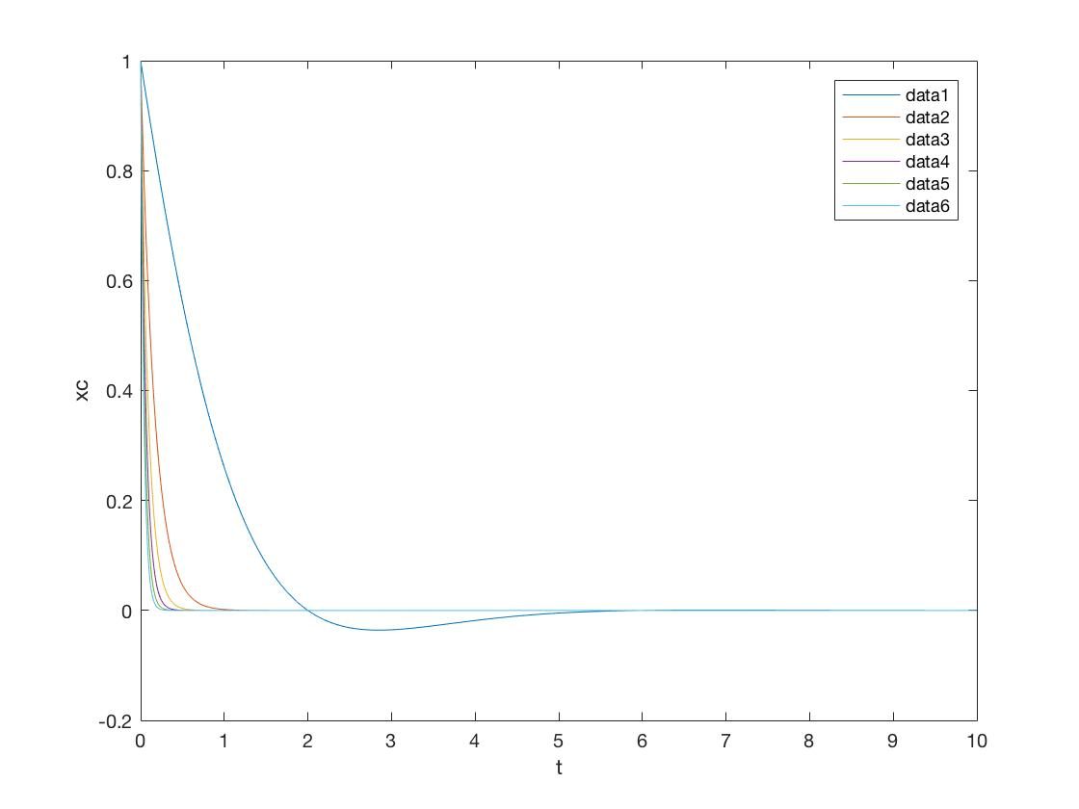

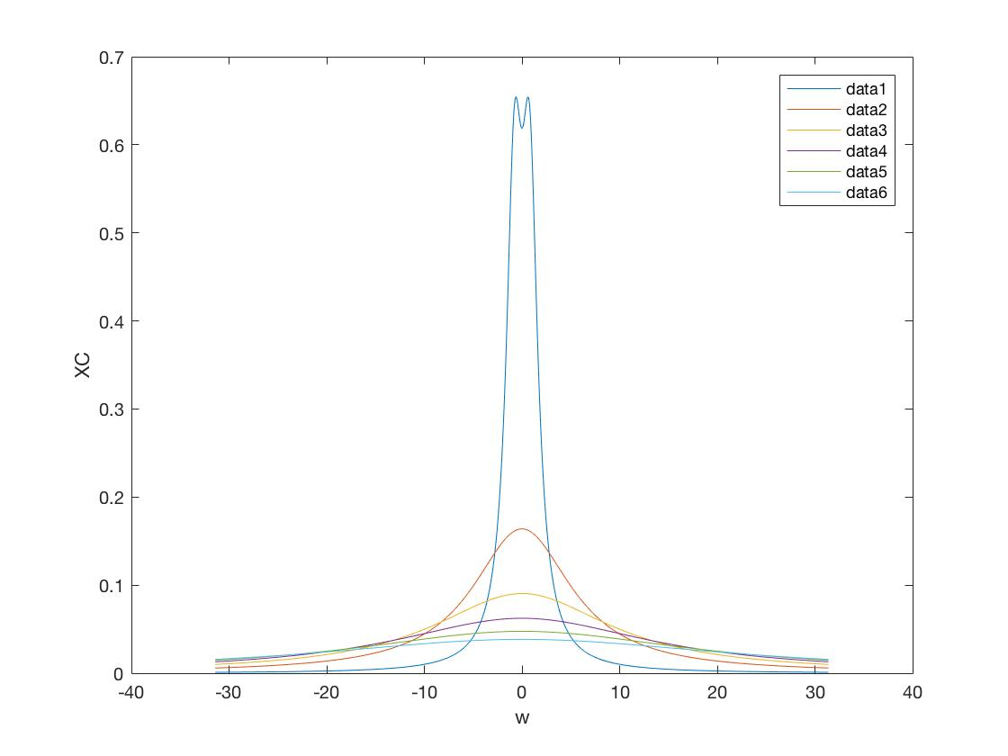

Fix $a$, change $Ω_{1}$. The diagram of $x_{c}\left(t\right)$ and $X_{c}\left(jΩ\right)$ showed as below:

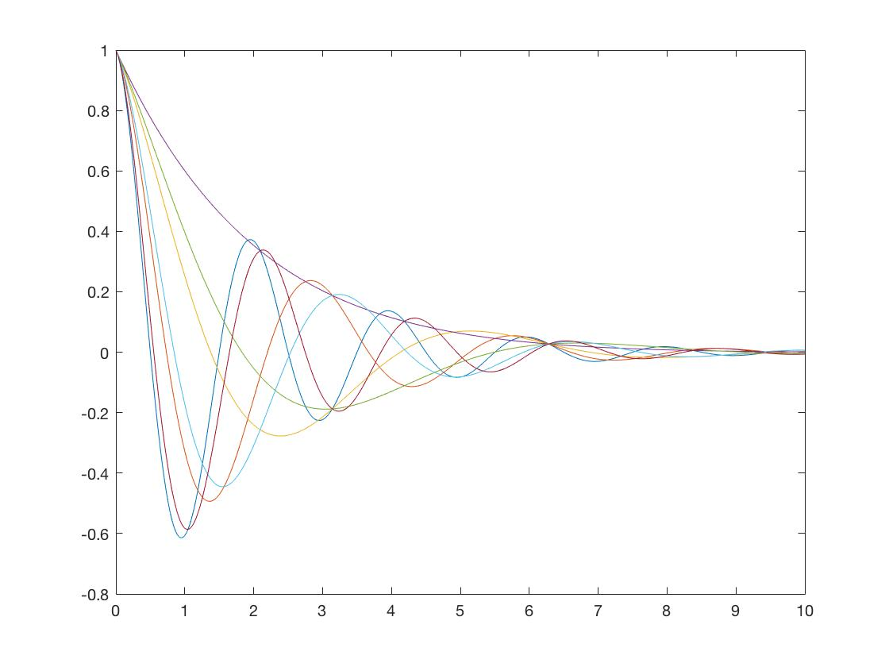

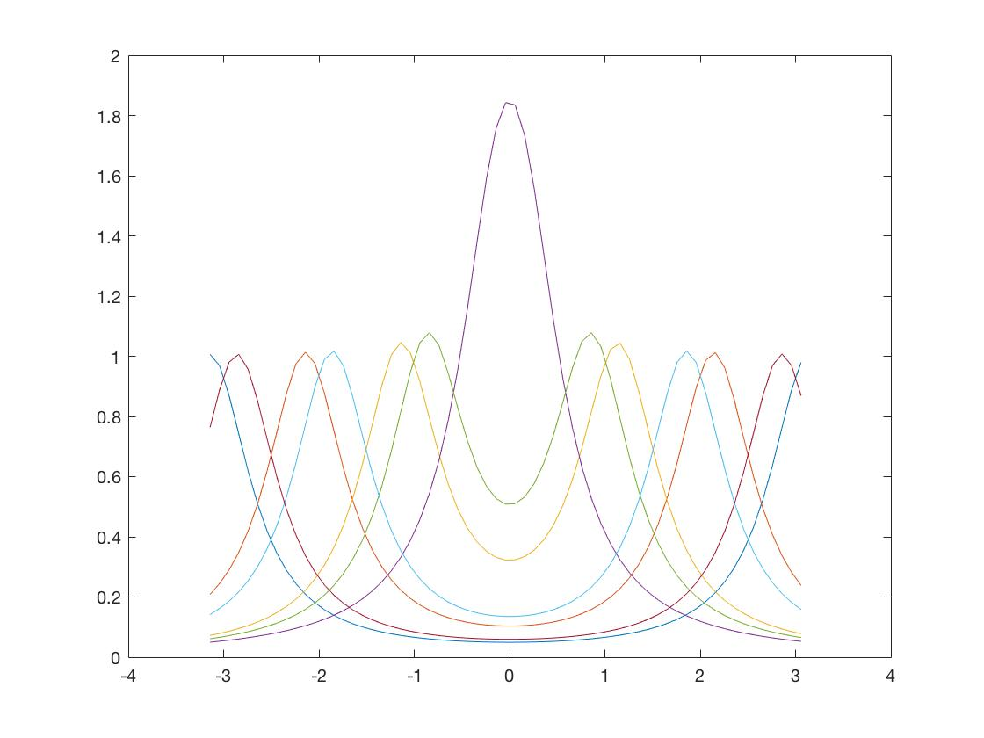

From the diagram, it can be observed that if keep the value of $Ω_{1}$, then changing $a$, for $x_{c}\left(t\right)$, the rise time and set time are changed with $a$, for $X_{c}\left(jΩ\right)$, the peak value increases with $a$, but the number of peak decreases as $a$ goes up. While if $Ω_{1}$ is changing, $a$ is a constant.

From the graphs, they show that there are more vibration before the curve coms to a stable value in $x_{c}\left(t\right)$. Meanwhile, with the changing of $Ω_{1}$, the number of peak decreases as the value of $Ω_{1}$ close to 0, while the curve becomes lower with the increasing of $Ω_{1}$.

The code in Matlab to get the diagram

Fix $Ω_{1}$, change $a$:

%xc = exp(-a*t)*cos(OMG1*t), XC = (a+jw)/((a+jw)^2+OMG^2)

%fix OMG, change a

clc

clear all

%a = 0.12;

for a = (1:5:30);

    OMG = 0.25*pi;

    %xc = exp(-a.*t).*cos(OMG1.*t);

    t = (0:0.01:10);

    w=(-10*pi:0.1:10*pi);

    xc = exp(-a.*t).*cos(OMG.*t);

    XC = (a+1i*w)./((a+1i*w).^2+ OMG.^2);

    figure(1);

    plot(t, xc);

    xlabel('t');

    ylabel('xc')

    hold on

    figure(2);

    plot(w, XC);

    xlabel('w');

    ylabel('XC')

    hold on

end

Fix $a$, change $Ω_{1}$:

%xc = exp(-a*t)*cos(OMG1*t), XC = (a+jw)/((a+jw)^2+OMG^2)

%fix a, change OMG

clc

clear all

a = 0.5;

for OMG = -pi:pi

    %OMG = 0.25*pi;

    %xc = exp(-a.*t).*cos(OMG1.*t);

    t  = [0:0.01:10];

    xc = exp(-a.*t).*cos(OMG.*t);

    figure(1);

    plot(t, xc);

    hold on

    figure(2);

    w = [-pi:0.1:pi];

    XC = (a+1i*w)./((a+1i*w).^2+ OMG.^2);

    plot(w, XC);

    hold on

end

b)

If $x\left[n\right]=x_{c}\left(nT\right)=\left\{\begin{aligned}e^{-anT}\cos{{(Ω}_{1}nT}), nT≥0,a>0. \\ 0, nT<0. \end{aligned}\right.$

$$X\left(e^{jω}\right)=\sum_{n=-∞}^{∞}{x\left[n\right]e^{-jω}}$$

$$=\sum_{-∞}^{∞}{e^{-anT}\cos{(Ω_{1}nT})e^{-jωn}}$$

DTFT of $e^{-anT}$ is

$$\sum_{-∞}^{∞}{{{(e}^{-(aT+jω)})}^{n}=\frac{1}{1-e^{-aT}e^{-jω}}}$$

If $α=e^{-aT}$,

DTFT of $e^{-aT}$ is $\frac{1}{1-αe^{-jω}}$ $=X_{1}(e^{jω})$

$$∴X\left(e^{jω}\right)=\frac{1}{2}[X_{1}\left(e^{j\left(ω+Ω_{1}T\right)}\right)+X_{2}(e^{j(ω-Ω_{1}T)})]$$

$=\frac{1}{2}[\frac{1}{1-e^{-aT}e^{-j\left(ω+Ω_{1}T\right)}}+\frac{1}{1-e^{-aT}e^{-j(ω-Ω_{1}T)}}]$

c)

The diagram of $X_{c}\left(jΩ\right)$

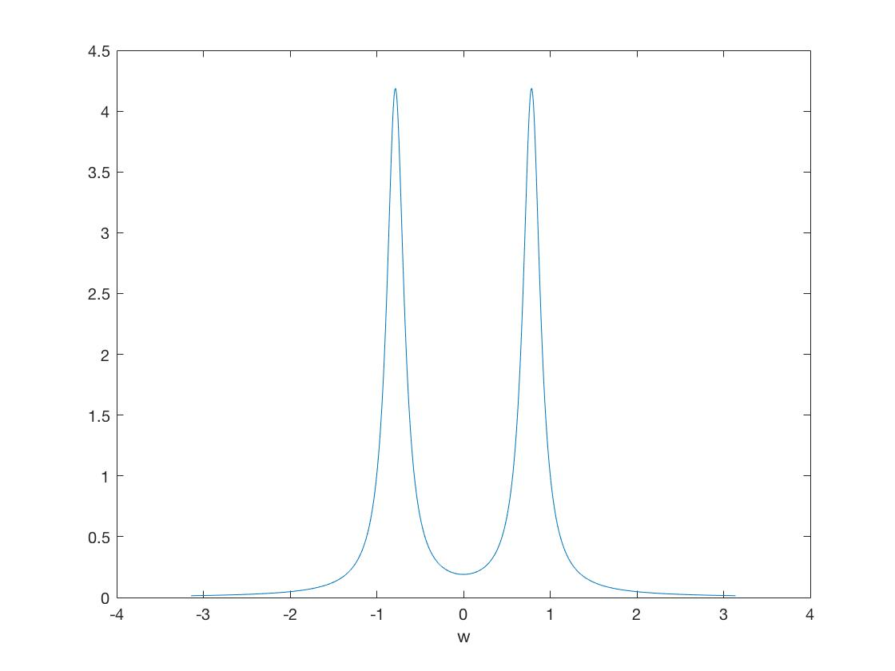

The diagram of $X\left(e^{jω}\right)$

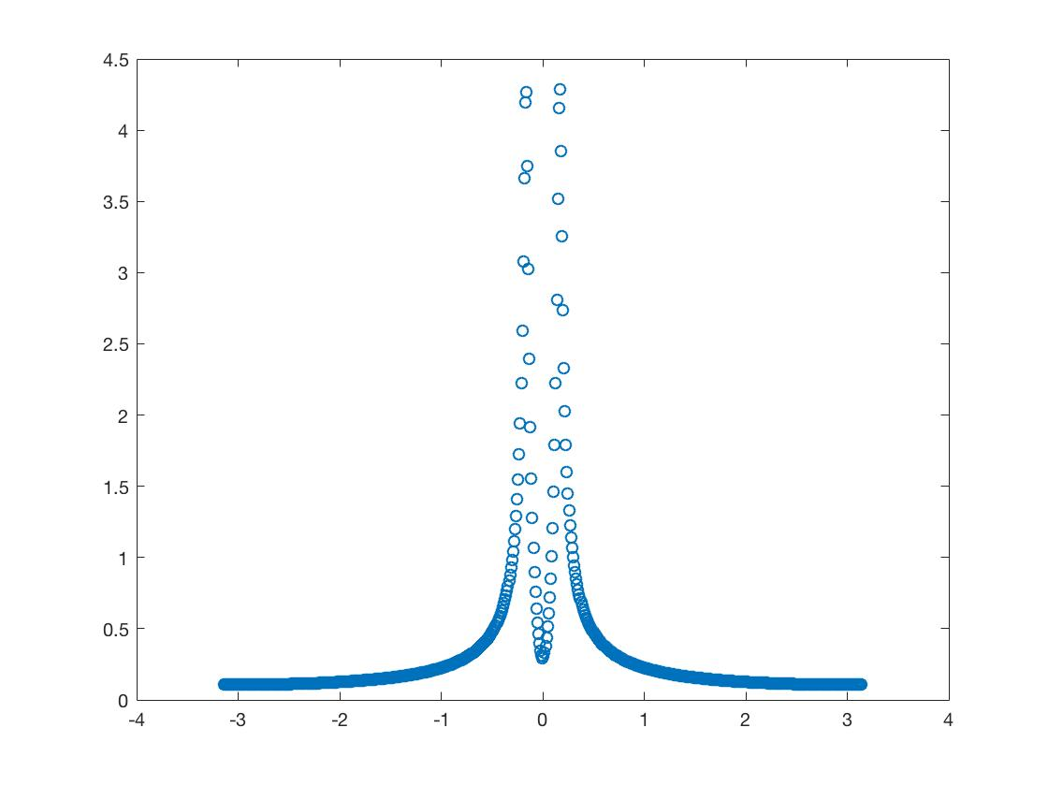

The command **freqz ,** [f w] = freqz (A , B , w), returns the frequency response vector f, and the corresponding angular frequency vector w, for the digital filter with numerator and denominator polynomial coefficients stored in B and A, respectively.

The code in Matlab to plot $X\left(e^{jω}\right)$

%XC after sampling is

clear all

clc

close all

a = 0.12;

OMG = 0.25*pi;

T = 1/4.8;

%fundamental frequency range

w = -pi:0.01:pi;

XC = (a+1i*w)./((a+1i*w).^2+ OMG.^2);%continues time FT

%abs(xc) only plot the magnetude

%NOW plot the sampled DTFT

A = [1 -exp(-a*T)*cos(OMG*T) 0];

B = [1 -2*exp(-a*T)*cos(OMG*T) exp(-2*a*T)];

[f w] = freqz (A , B , w);

hold on;

%w/T=continuous time frequency

%abs(f)*T

figure(2);

plot ( w, abs(f)*T, 'o');

hold on

end

d) Proof:

If $H_{LP}\left(Z\right)=\frac{1-α}{2}\frac{1+Z^{-1}}{1-αZ^{-1}}$

$H_{LP}\left(e^{jω}\right)=\frac{1-α}{2}\frac{1+e^{-jω}}{1-αe^{-jω}}$

From Euler Formula $H_{LP}\left(e^{jω}\right)=\frac{1-α}{2}\frac{1+\cos{ω}-j\sin{ω}}{1-α\cos{ω}+αj\sin{ω}}$

$$\left|H_{LP}(e^{jω})\right|=\frac{1-α}{2}\frac{\sqrt{{(1+\cos{ω})}^{2}+\sin^{2}{ω}}}{\sqrt{{(1-α\cos{ω})}^{2}+α^{2}\sin^{2}{ω}}}$$

$=\frac{1-α}{2}\frac{\sqrt{2+2\cos{ω}}}{\sqrt{1+α^{2}-2α\cos{ω}}}$

$${\left|H_{LP}{(e}^{jω})\right|}^{2}=\frac{{(1-α)}^{2}}{2}\frac{1+\cos{ω}}{1+α^{2}-2α\cos{ω}}$$

$=\frac{{\left(1-α\right)}^{2}(1+\cos{ω})}{2(1+α^{2}-2α\cos{ω})}$

Focus on the stability

Because $H_{LP}\left(Z\right)=\frac{1-α}{2}\frac{1+Z^{-1}}{1-αZ^{-1}}$

$=\frac{1-α}{2}\frac{Z+1}{Z-α}$

The only pole of the signal is $Z=α$;

So $\left|α\right|≤1$ and $1-α≠0$;

$$∴-1<α<1$$

$$\left|H_{LP}(e^{jω})\right|=\frac{1-α}{2}\frac{\sqrt{2+2\cos{ω}}}{\sqrt{1+α^{2}-2α\cos{ω}}}$$

$$∠H_{LP}\left(e^{jω}\right)=\cot\left(-\frac{\sin{ω}}{1+\cos{ω}}\right)-\cot{(\frac{α\sin{ω}}{1-α\cos{ω}})}$$

Plot $\left|H_{LP}(e^{jω})\right|$ and $∠H_{LP}\left(e^{jω}\right)$

Diagram of $\left|H_{LP}(e^{jω})\right|$

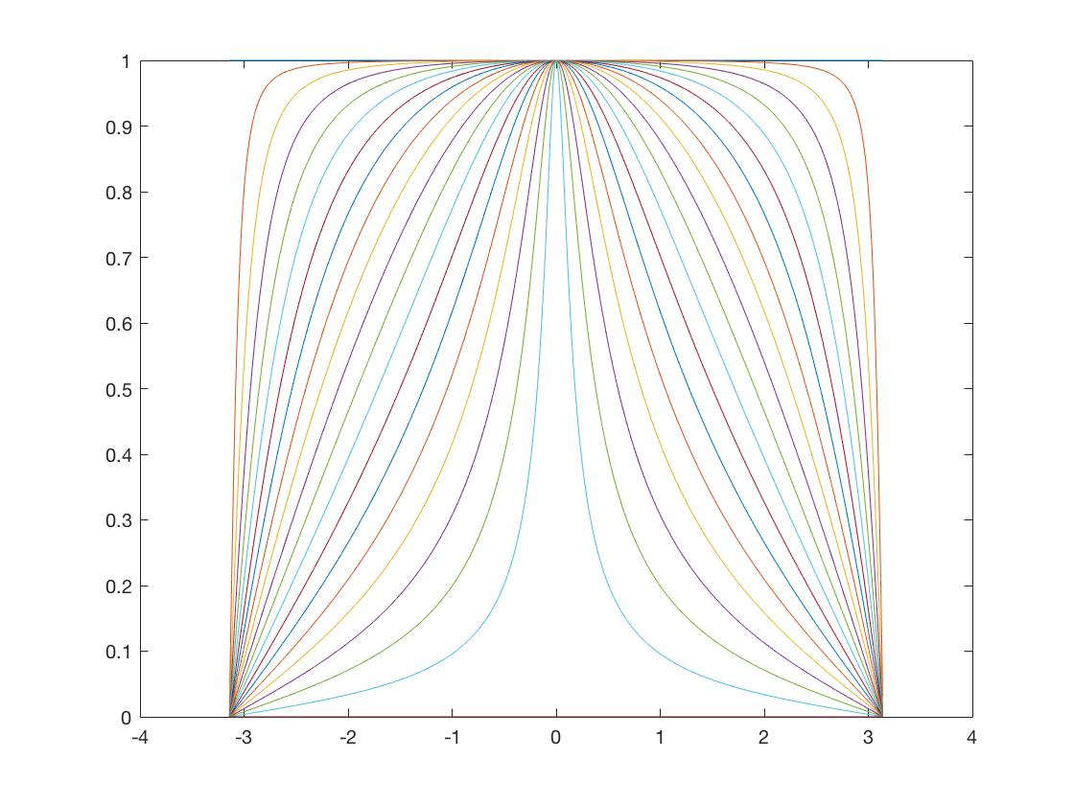

Diagram of $∠H_{LP}\left(e^{jω}\right)$

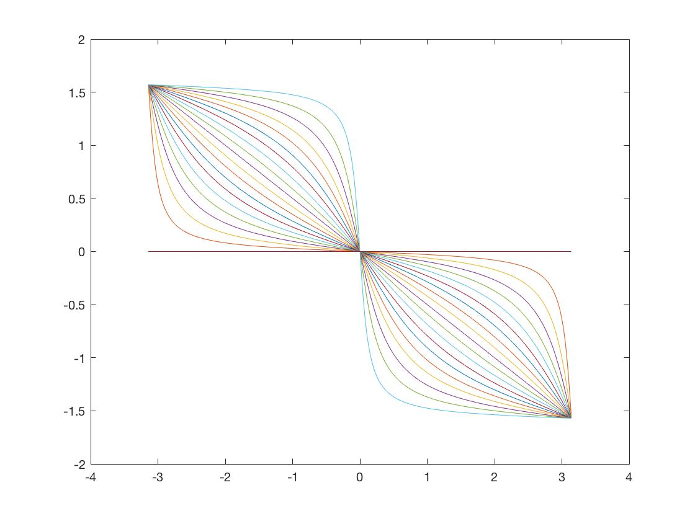

From the diagram above it can be observed that as the value of $α$ changing from -1 to 1, the peak of diagram of $\left|H_{LP}(e^{jω})\right|$ does not change, but the value of [-1,0] and [0,1] are closer to 0 as the increasing of $α$.

When talking to diagram of $∠H_{LP}\left(e^{jω}\right)$, if the value of $α=0$, then the curve of $∠H_{LP}\left(e^{jω}\right)$ is just like the function y=-x. When $-1<α<0$, the relative curves of $∠H_{LP}\left(e^{jω}\right)$ are all below the curve which has $α=0$. As the $α$ becomes smaller, the curves are closer to real axis. When the $0>α>1$, the relative curves are all above the curve which has $α=0$. With the increasing of value of $α$, these curves are closer to the imaginary axis.

The code in Matlab to plot the diagram of $\left|H_{LP}(e^{jω})\right|$ and $∠H_{LP}\left(e^{jω}\right)$

clear all

clc

%H = (1 - a) / 2 * (1 + 1/z) / (1 - a/z)

%where z = e^jw=exp(i*w), where w = -pi :0.01: pi

%and a should vary

%a = 0.8;

for a = -1:0.1:1;

    H = zeros(0, 629);

    i = 1;

    for w = -pi :0.01: pi

        z = exp(j*w);

        H(i) = (1 - a) / 2 * (1 + 1/z) / (1 - a/z);

        i = i+1;

    end

     figure(1);

     plot(-pi :0.01: pi, abs(H));

     hold on;

    figure(2);

    plot(-pi :0.01: pi, angle(H));

    hold on;